10/1/2023

Zoya Azad

231579

**Lab Assignment 1**

***Programming fundamentals***

**Programming Fundamentals**

**BSCS**

**Question 1**

**Part 1:**

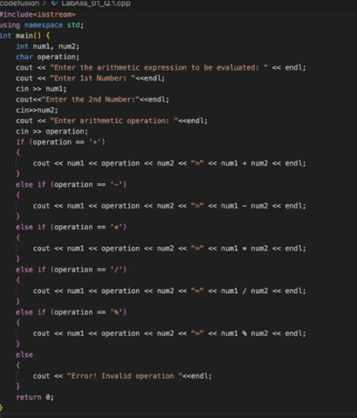

**Part 2:**

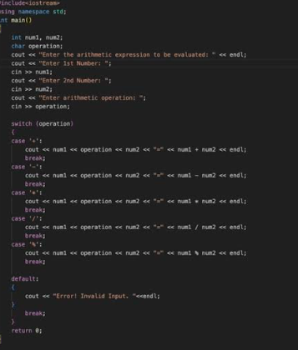

**Output:**

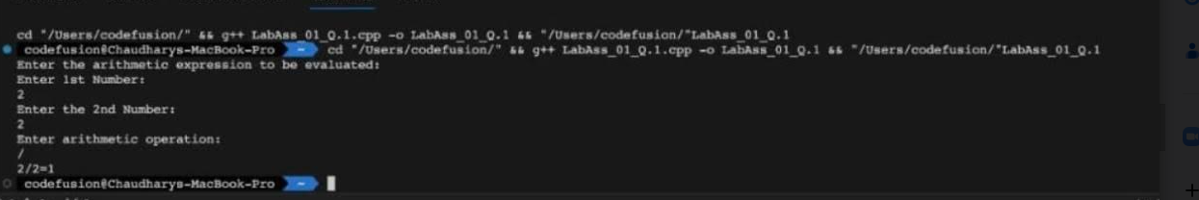

**Explanation:**

* In the following program the user is asked to enter two values of int data type and one value of char data type.
* The program then performs the selected operation in the given two numbers
* We have used both switch and if else statement as per the requirement of the program.
* In case of an invalid operator, an error message will be displayed.

**Question 2:**

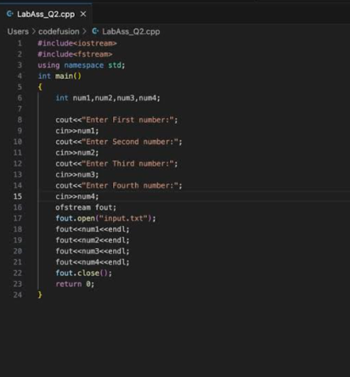

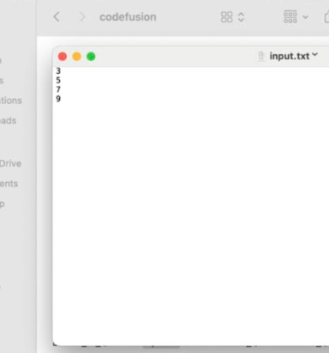

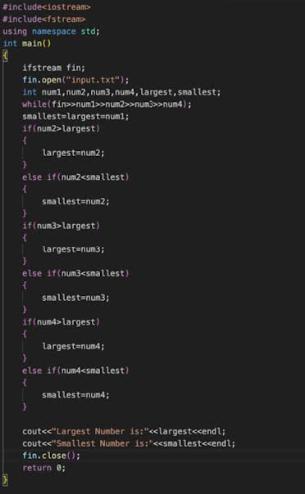

**Output:**

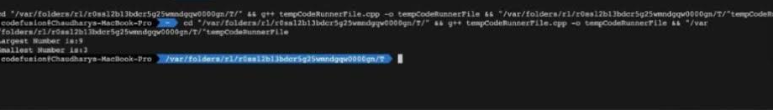

**Explanation:**

* First we created an output file where we stored these values (3,8,6,9).
* Then we used an input file and took the saved data from output file and used it in another program.
* We used if else if statement to see which number is largest and which number is smallest.
* After compiling and running the program we get the output.
* 9 and 3 are the largest and smallest numbers respectively.

**Question no 3 :**

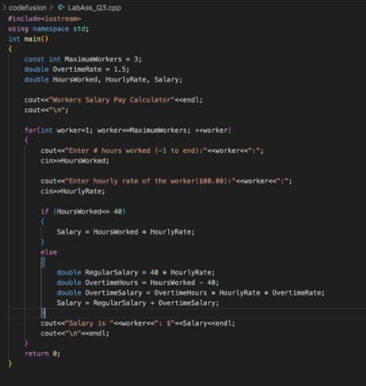

**Output:**

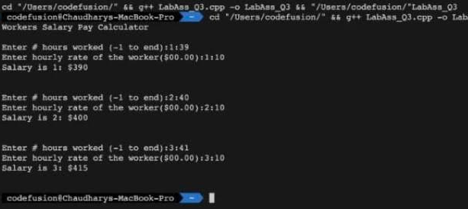

**Explanation:**

* First we define a constant variable for maximum workers ( as per the requirement ) and overtime rate to represent multiplier for overtime rate.
* We are using for loop to go through all three workers.
* For each worker, we will ask the user to enter the hours worked and the hourly rate.
* Now we will use the if statement within the for loop.
* If the hours worked are less than or equal to 40, then we calculate salary by:

Salary = Hours worked * hourly rate

* If the hours worked are greater than 40 then we calculate the salary by:

Salary = Overtime hours* hourly rate* overtime rate

* The salary of each employee will be displayed.

**Question 4:**

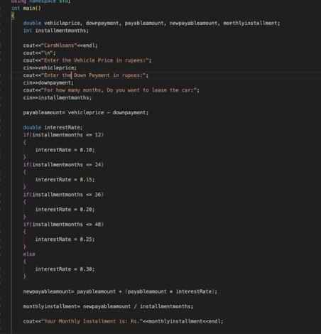

**Output:**

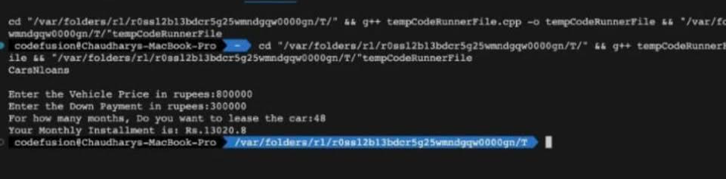

**Explanation:**

* We ask the user to enter the vehicle price, down payment, and installment months.
* We calculate the payment amount with this formula:

Vehicle price – down payment

* Based on the number of installment months , we determine the appropriate interest rate.
* Now we will calculate the new payable amount with the applied interest rate.
* Finally we will calculate the monthly installment and it will be displayed to the user.

Vehicle price – down payment